<https://design-development-web.vercel.app/>

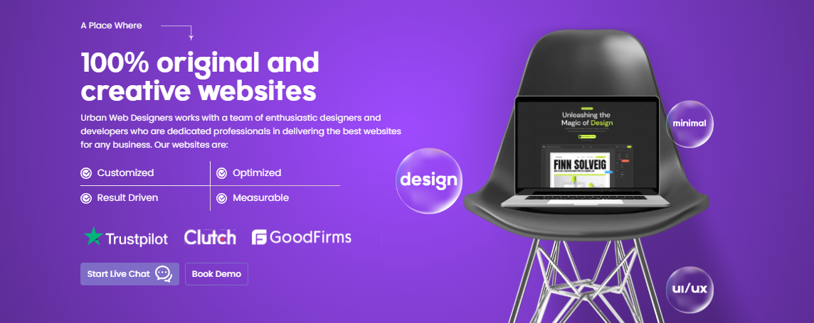

Top Web Design Company

**Creating 100% Original Custom Website Designs**

Frustrated by underperforming web designs? It's time for a change and we can help. Website Design Hub is trusted by businesses nationwide. We are a top-rated and affordable web design company, known for creating websites that are:

* Interactive
* Responsive
* SEO-Optimized
* Conversion-Focused

**CTA:**

Start Live Chat

Call Us **OR** Contact Us



**Our Web Design Agency Takes Center Stage in Every Field of Design**

Web Design Hub has an In-house team of devoted professional web designers and developers, who are dedicated to delivering top-tier websites for businesses. Our website solutions include:

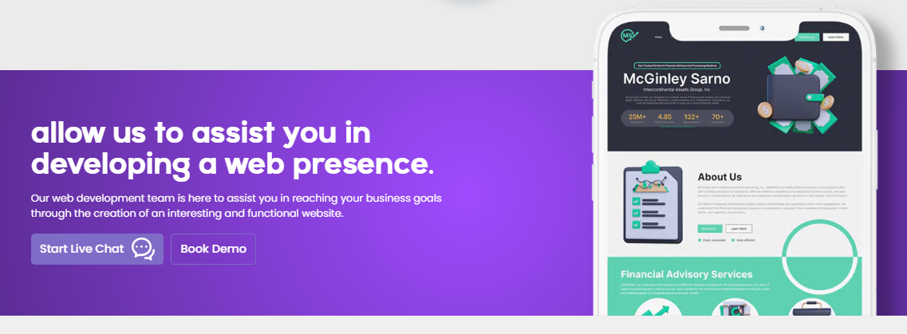

**Let us develop a responsive website to help you attract more visitors, and drive greater business success.**

Our professional web development team is at your service, dedicated to design and develop dynamic websites that urges visitors to take *your* desired action on the website.

**CTA:**

Start Live Chat

Call Us **OR** Contact Us

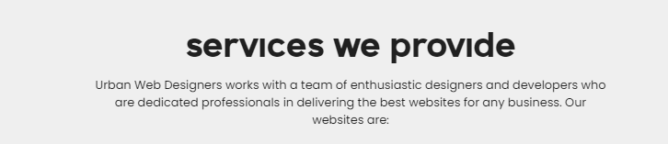

**Designing and Developing Digital Delights**

We specialize in custom logo design, mobile application design and website development. Our diverse team at Web Design Hub excels in digital marketing, SEO, and delivering persuasive copywriting.

**CTA:**

Start Live Chat

Call Us **OR** Contact Us



**Explore Our Design Portfolio, Your Success is Our Mission**

At Web Design Hub, our designers are committed to excellence in every aspect of design, from logos to web, mobile apps, and illustrations.

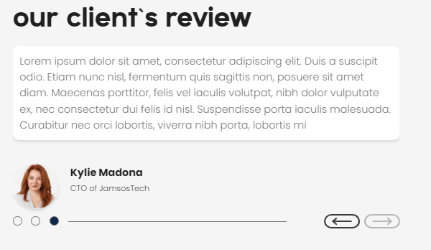

*"Web Design Hub created a special and eye-catching custom logo design that perfectly shows what our financial consulting firm is about. Our team and clients love it, thanks to their amazing logo design skills."*

**Jennifer Mitchell**

Senior Financial Advisor

**WealthVision Consultants**

*“Their UI/UX web design service has significantly improved the visual appeal and functionality of our ecommerce website across devices. The user engagement on our website has increased a lot as well. Web Design Hub is the best web design company I have ever worked with.”*

**Sarah Johnson**

E-commerce Manager

**Urban Bloom Boutique**

*“Hiring Web Design Hub for our tech startup web design and development has been one of the best decisions. It's not just about aesthetics; the functionality and user experience they delivered are nothing short of exceptional.”*

**Emily Parker**

Co-founder

**InnovateTech Solutions**

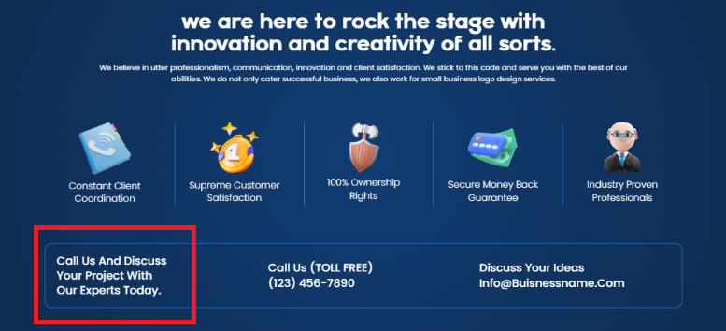

**We Make *'Wow'* Happen at Web Design Hub**

Our professional web designers and developers prioritize communication, innovation, and your satisfaction. We serve both large and small businesses with top-tier logo design services.

* Responsive Customer Support
* Customer Satisfaction Guaranteed
* Ownership Protection
* Budget-Friendly Pricing
* Industry Professionals

You Are Just A Call Away From Securing A Spectacular Design.

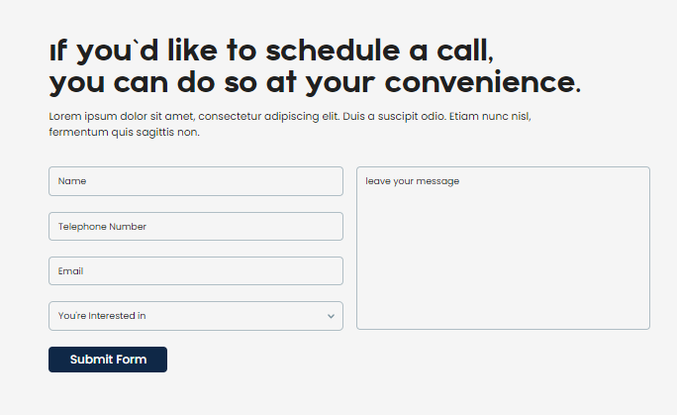

**Design Solutions at Your Fingertips – Schedule a Call at Your Convenience with Us!**

Do not miss this chance to take the first step toward discussing a custom design solution for your website, logo and mobile application. Book a call now!

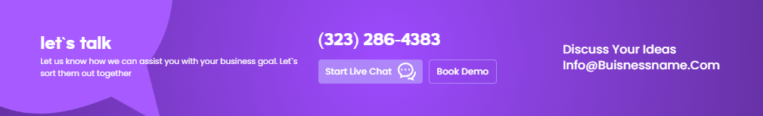

**Design Consultation**

Contact us for a free consultation, and let's design your captivating logo, website, and mobile app together!

**CTA:**

Start Live Chat

Call Us **OR** Contact Us

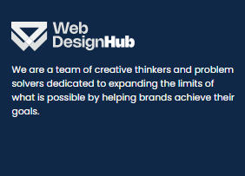

Web Design Hub excels in making custom logos, responsive website design and development. Our expert UI/UX designers contribute to your brand’s success with visually stunning and functional designs.